Nama : Talitha Ayu Prasafa

Nim : 17050623009

Prodi : DIII Manajemen Informatika

**StrukturDatabase :**

Lcd

Cpu

Apple

Windows

Software

Hardware

Product

Orders

* Model Tree Structures with Materialized Paths

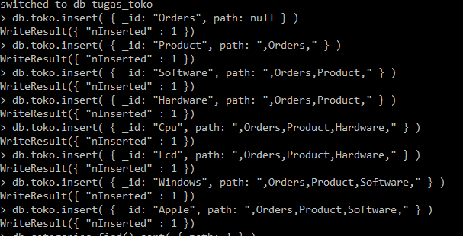

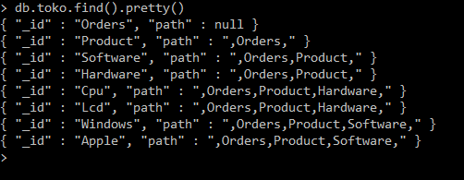

* Model Tree Structures with an Array of Ancestors

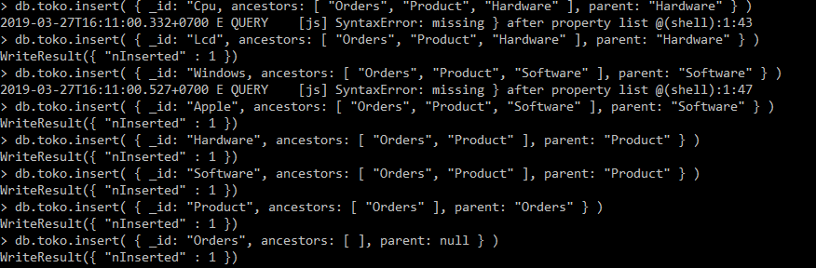

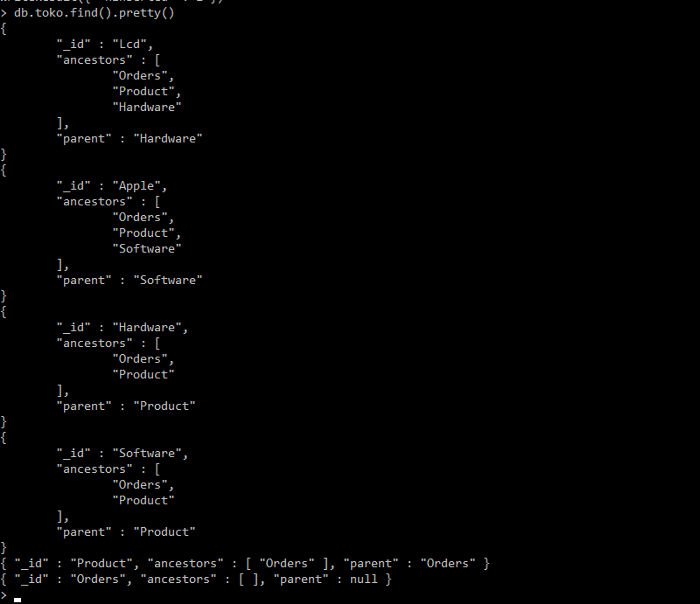

* Model Tree Structures with Child References

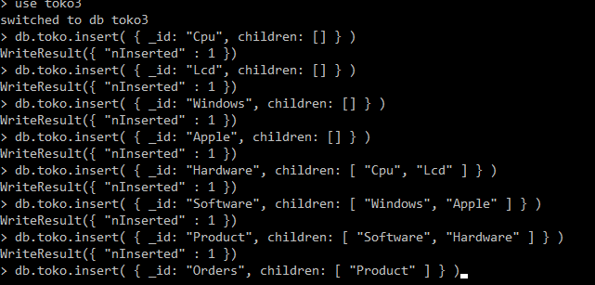

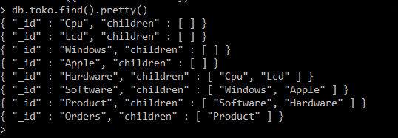

* Model Tree Structures with Parent References

